Parent Session
Supporting your Child with their Learning at Home

An evening session for parents of struggling learners on:

- New ideas and strategies to help your child complete their homework easily and with less stress
- Boosting you and your child’s confidence working together
- Finding out how they think and learn best
- For learners aged 6 to 16

Course date: Tuesday 27th February 6.30 – 7.30 pm

Venue: Trinity School, Seal Hollow Rd, Sevenoaks TN13, 3SL 01732 469111
Neil MacKay:
An independent international educational consultant and trainer.
Author of:

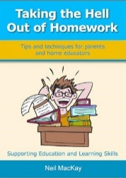

Cost: Free

Please book your place on

